CS 255 System Design Document

UML Diagrams

UML Use Case Diagram
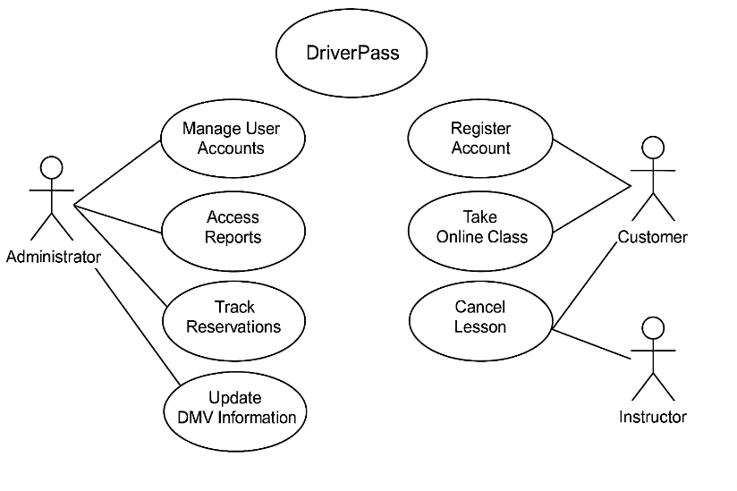
In this use case diagram, each actor is represented using standard UML stick-figure notation, and each action is modeled as a use case with proper oval symbols. The associations between actors and use cases use solid connector lines, clearly showing which roles interact with which system functions. This notation ensures the system’s functional boundaries and user interactions are easy to understand and accurately represented.

UML Activity Diagrams
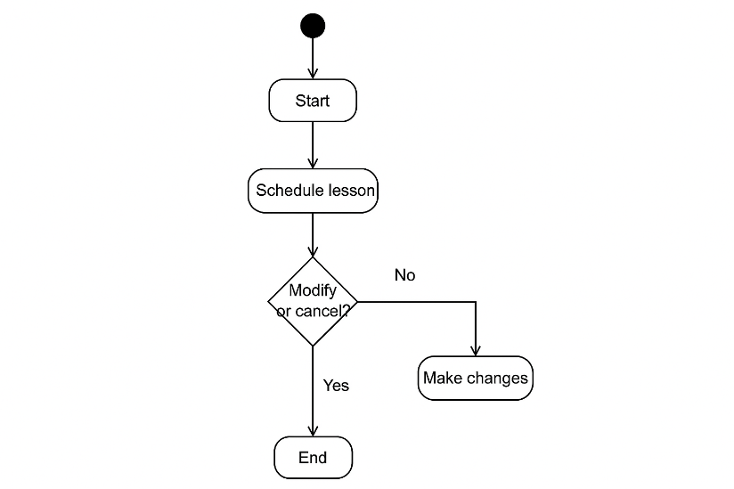
This activity diagram illustrates the detailed steps a student or staff member follows to schedule, modify, or cancel a driving lesson. It shows how the system checks availability, verifies instructor and vehicle assignments, updates the schedule, and prevents double-bookings. This ensures a smooth and reliable appointment process.

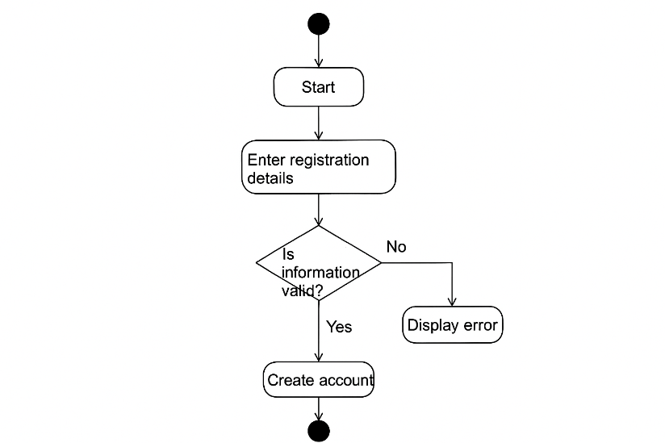
This activity diagram shows the steps a new customer follows to create an account. It highlights how the system collects user information, validates the data, handles errors, and creates the account once all information is confirmed. This ensures accuracy and prevents issues later when scheduling or accessing training materials.

UML Sequence Diagram
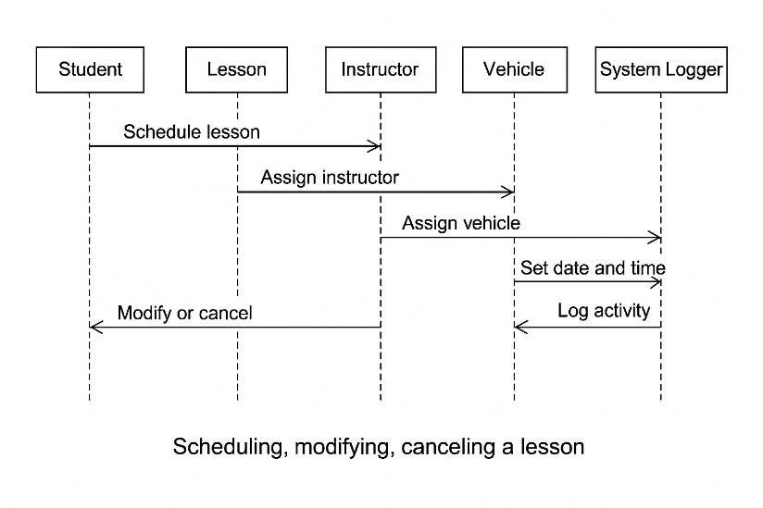
This sequence diagram shows how different parts of the system interact over time to complete a single task (such as scheduling a lesson or updating an account). It demonstrates the order of messages between the user interface, system logic, and database. This helps ensure every action is processed correctly and consistently.

UML Class Diagram
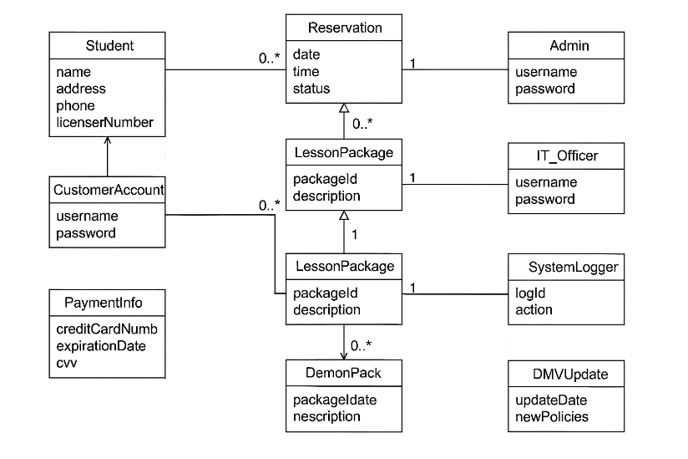
The class diagram identifies the major data structures in the DriverPass system, such as students, instructors, vehicles, appointments, training packages, and user accounts. It shows the attributes stored for each class and the relationships between them. This diagram forms the foundation for the database design and ensures the system can store and manage all required information.

Technical Requirements
Hardware Requirements
• Secure cloud-hosted servers capable of supporting the web application, scheduling engine, and database with high uptime.
• End-user devices such as desktops, laptops, tablets, and mobile phones capable of running a modern web browser.
• Reliable high-speed internet connectivity for both staff and customers, since all core functions depend on online access.
• Optional office workstations for the secretary, owner, and instructors, ensuring fast access to administrative dashboards.

Software Requirements
• Modern web browsers (Chrome, Firefox, Safari, Edge) with JavaScript and cookies enabled.
• Server-side software framework capable of supporting authentication, role-based access, lesson scheduling logic, and secure data processing.
• A relational database management system storing users, instructors, lessons, vehicles, packages, DMV updates, and activity logs.
• Secure API or automated data connection for receiving DMV rule updates and new practice test material.
• Email and notification service for password resets and account confirmations.
• Encryption libraries to ensure all stored and transmitted data remains protected.
Tools
• CASE tools such as Lucidchart for maintaining system diagrams and supporting future system modifications.
• Development tools such as Git for version control, an IDE for building system updates, and automated deployment tools.
• Administrative control panels used by the secretary, owner, and IT officer for managing appointments, user accounts, instructor schedules, and system content.
• System monitoring and reporting tools used by IT to review server health, logs, and error reports.
Infrastructure Requirements
• Cloud hosting platform (AWS, Azure, or similar) offering redundancy, autoscaling, and managed backups.
• HTTPS/SSL encryption for all communication between user devices and the server.
• Role-based access control ensuring users can only perform allowed actions, with elevated permissions restricted to staff and IT.
• Full activity logging for accountability, including record creation, modification, and cancellation tracking.
• Encrypted data storage using industry-standard encryption for sensitive information including credit card details, personal information, and driving history.
• Disaster recovery mechanisms, such as automated backups, database replication, and recovery point objectives aligned with business needs.

